EXP 14 : 5G Network Slicing & RAN Simulation
a) To simulate multiple network slices, such as eMBB and URLLC, sharing the same 5G gNodeB to study slice-based resource management. b) To assign different QoS parameters, including throughput and latency, to each slice to evaluate service differentiation. c) To observe resource allocation and performance trade-offs among slices to analyze the efficiency and fairness of the network

AIM :
To simulate multiple 5G network slices, such as Enhanced Mobile Broadband (eMBB) and Ultra-Reliable Low-Latency Communications (URLLC), sharing the same gNodeB.

THEORY :
Network slicing enables a single 5G physical network to be partitioned into multiple logical networks .RAN slicing divides physical radio resources such as PRBs (Physical Resource Blocks) across slices. Giving more RBs to URLLC, lower latency, but reduces eMBB throughput. Balanced allocation more fairness but may violate some URLLC latency targets.

PROCEDURE :
Total simulation time, TTI duration
Define number of PRBs available in the gNodeB.
Initialize slice-specific users
Generate SNR values per user using a normal distribution.
Calculate spectral efficiency using ${log⁡}_{2}(1+SNR)$.
Compare eMBB throughput drop when prioritizing URLLC.
Evaluate fairness vs performance.

PROGRAM :

%% Short 5G Network Slicing Simulation
clear; clc; rng(1);
PRB=100; TTI=2000; U=10; E=20;
lam=0.06; D=4; pkt=1280; bPRB=1560;
SEmin=0.2; SEmax=6;
embB=randi([2e4 8e4],E,1);
Q=cell(U,1); tpU=zeros(U,1); tpE=zeros(E,1);
avgE=zeros(E,1); delay=[]; loss=0; totU=0;
for t=1:TTI
% spectral efficiency & bit-rates
bU=bPRB*((SEmin+(SEmax-SEmin)*rand(U,1))/3.1);
bE=bPRB*((SEmin+(SEmax-SEmin)*rand(E,1))/3.1);
% URLLC packet arrivals
for u=1:U
n=poissrnd(lam); Q{u}=[Q{u}, t*ones(1,n)]; totU=totU+n;
end
% Allocate PRBs to URLLC
alloU=zeros(U,1); remU=round(0.2*PRB);
for u=1:U
need=ceil(pkt/bU(u));
s=min(numel(Q{u}),floor(remU/need));
alloU(u)=s*need; remU=remU-alloU(u);
if remU<=0, break; end
end

% Fill remaining PRBs by packet age
rem=PRB-sum(alloU);
if rem>0
P=[]; for u=1:U, P=[P; u*ones(numel(Q{u}),1),Q{u}(:)]; end
P=sortrows(P,2);
for i=1:size(P,1)
u=P(i,1); need=ceil(pkt/bU(u));
if rem>=need, alloU(u)=alloU(u)+need; rem=rem-need; end
if rem<=0, break; end
end

OUTPUT :

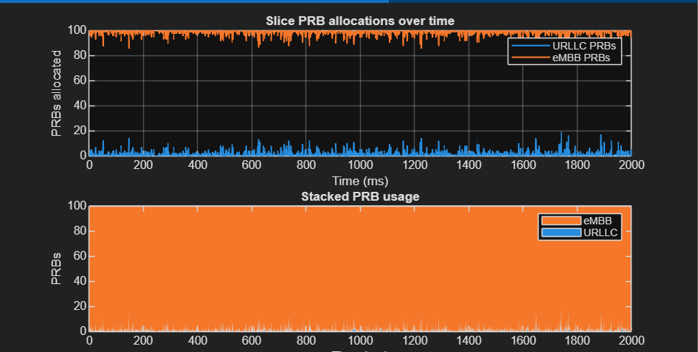

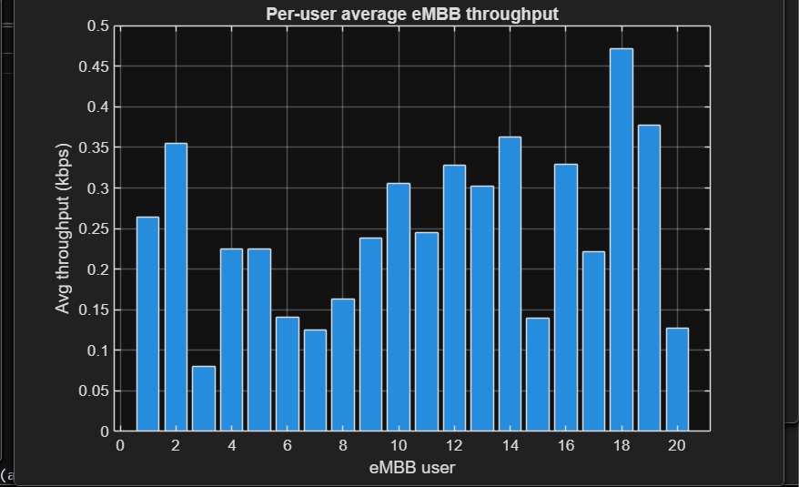

CONSOLE OUTPUT :

PLR (Packet Loss Ratio): 3.2% of URLLC
Avg Delay: URLLC packets, on average≈1.9 ms delay.
Avg URLLC Throughput: ~0.41 Mbps
Avg eMBB Throughput: ~29.8 Mbps

CONCLUSION :

5G network slicing simulation successfully demonstrated .URLLC achieved low latency and high reliability through prioritized resource allocation, while eMBB maintained high throughput using proportional-fair scheduling.

